Experiment worksheet

5.1 Physical change is a change in shape or appearance

Pages 80–81 and 190

Challenge 5.1: Exploring physical changes

What you need

• Aluminium drink can

• Elastic/rubber band

• Rock salt

• Ice

• Sugar cube

• Vitamin C tablet

• Slice of bread

• Piece of cloth

• Scissors

What to do

1 For each of the materials provided, find ways to change its physical appearance.

2 Record the method you used and your observations in Table 1.

Discussion

1 List three different ways in which a physical change can take place.

2 What did each change have in common?

Table 1

|  |  |  |  |
| --- | --- | --- | --- |
| **Material** | **Method Used** | **HAs the substance changed?** | **Can the change be reversed/undone?** |
|  |  |  |  |
|  |  |  |  |
|  |  |  |  |
|  |  |  |  |
|  |  |  |  |
|  |  |  |  |
|  |  |  |  |
|  |  |  |  |
|  |  |  |  |

Experiment worksheet

5.1 Physical change is a change in shape or appearance

Pages 80–81 and 189

Experiment 5.1: Melting chocolate

Aim

To examine the physical change in melting chocolate

Materials

• Milk, dark and white cooking chocolate buttons (approximately ten of each)

• 3 × 100 mL beakers

• Thermometer

• 250 mL beaker (as a water bath)

• Stirring rod

• Bunsen burner and heating mat or hotplate

• Timer

Method

1 Place four to six buttons of milk cooking chocolate in a beaker.

2 Place a thermometer in the beaker.

3 Place the beaker in a hot water bath (or boiling water in a beaker) and heat it to 60°C. Do not stir the chocolate.

4 Time how long it takes to melt. Record your observations.

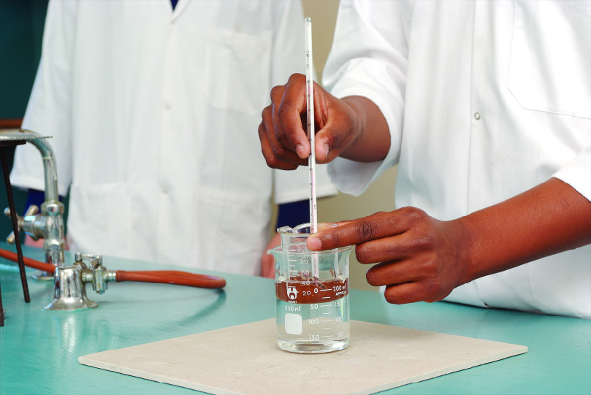

Figure 1Placing the small beaker of chocolate buttons in a beaker of boiling water causes the chocolate to melt.

Inquiry: What if another type of chocolate was melted? Would it melt faster or slower than milk chocolate?

• Write a hypothesis for your question.

• What (independent) variable will you change from the first method?

• How will you determine when the chocolate has melted?

• Name three variables you will keep the same/control.

• Record your observations and measurements in a table below.

Results

1 Record your observations, including any diagrams and photographs using the space provided.

|  |
| --- |
|  |

2 Draw a column graph below to record the time it took for each type of chocolate to melt.

|  |
| --- |
|  |

Discussion

1 Was there any difference in the time it took for each type of chocolate to melt?

2 Did all three types of chocolate melt in the same pattern? (Inside first or outside edges first?)

3 How could a chef apply your observations in the kitchen?

4 Did you burn any of the types of chocolate?

5 Did a new substance form? How can you tell?

Conclusion

What similarities and differences are there between milk, dark and white chocolate?

Experiment worksheet

5.2 Chemical change produces new substances

Pages 82–83 and 190

Challenge 5.2: Making caramel

What you need

• Sugar

• Test tube

• Test tube holder

• Bunsen burner and heating mat

What to do

1 Place a pea-sized amount of ordinary sugar into a dry test tube.

2 Wearing safety glasses and, with the test tube facing away from you and everyone else, gently heat the sugar by passing it through the top part of a blue flame.

3 If you are careful, the sugar grains will crumble (they lose water in a chemical reaction) and turn into a brown syrup. This brown syrup is caramel. You may see condensation on the inside of the test tube as the water is driven out of the sugar.

4 If you continue heating, or heat too strongly, you will burn the sugar. Charcoal residue is left behind. This is another chemical change.

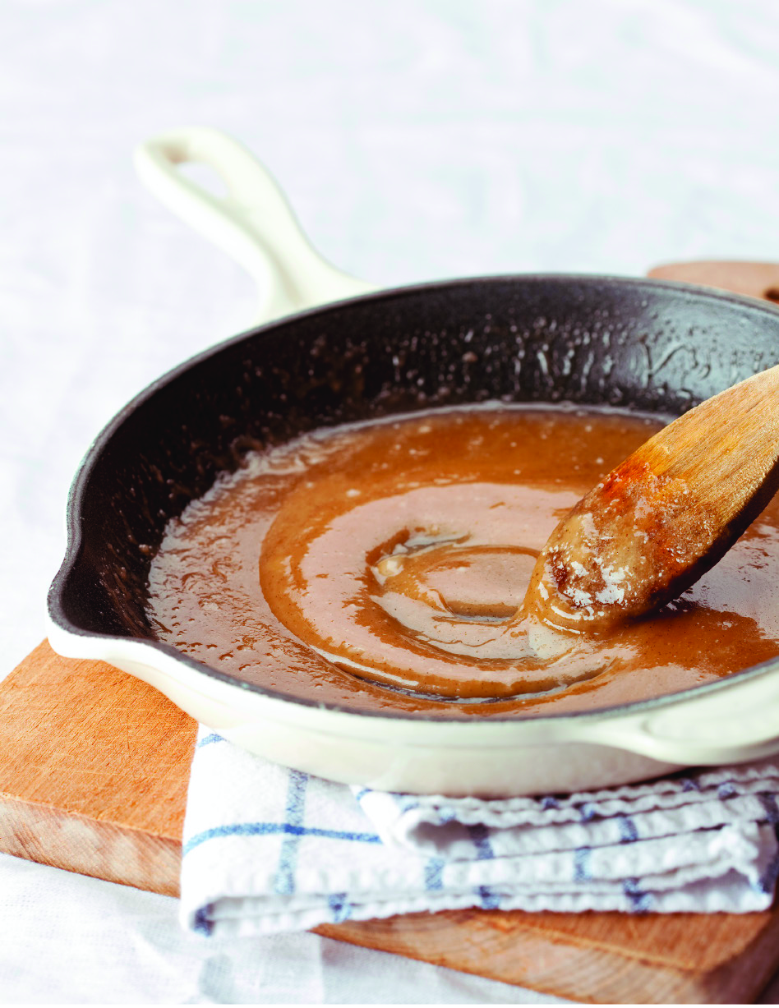

Figure 1 Heated sugar undergoes a chemical change.

Experiment worksheet

5.2 Chemical change produces new substances

Pages 82–83 and 191

Experiment 5.2: Observing chemical reactions

Aim

To observe the reactants and products in chemical reactions.

Materials

• Spatula

• Copper carbonate (solid)

• Bunsen burner and heating mat

• Matches

• Two test tubes and test tube holder

• Baking soda (sodium bicarbonate)

• 5 mL of 1 M hydrochloric acid

• Thermometer

• Wooden splint

• Magnesium ribbon (1 cm length)

• ~0.5 M copper sulfate solution

• 100 mL beaker

• Tongs

• Piece of steel wool, about thumb size when rolled up

Method

PART A

1 Place a large spatula of copper carbonate in a test tube.

2 Set up the Bunsen burner.

3 Using a test tube holder, gently heat the test tube by passing it over the flame twice. Make sure the test tube is facing away from you and everyone else. Observe any changes and repeat until the powder changes colour.

4 Collect the waste powder in a beaker for disposal.

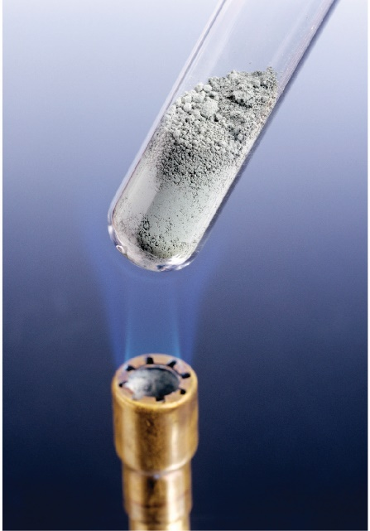

Figure 1When heating a test tube, be sure to point it away from you or anyone else close by.

PART B

1 Place the baking soda in a test tube to a depth of 0.5 cm.

2 Add an equal amount of 1 M hydrochloric acid to the test tube and observe.

3 Conduct a carbon dioxide test by holding a burning wood splint above the tube. If the flame goes out, carbon dioxide is present as one of the products of the chemical reaction.

PART C

1 Pour 5 mL of hydrochloric acid into the bottom of a test tube. Measure its temperature with the thermometer.

2 Add the magnesium ribbon to the test tube. Measure its temperature again.

3 Observe what happens using sight, touch (the outside of the tube only!) and sound.

PART D

1 Pour approximately 30 mL of the copper sulfate solution into a 100 mL beaker.

2 Use the tongs to place the steel wool into the copper sulfate solution.

3 Carefully observe the changes that occur to both the steel wool and the copper sulfate solution.

4 Collect the copper sulfate/steel wool solution in a beaker for safe disposal.

Results

Include your observations here.

|  |
| --- |
|  |

Discussion

1 What happened to the copper carbonate when it was heated?

2 Did it change when taken away from the heat?

3 Is this similar to the melting chocolate experiment? Why or why not?

4 What is produced in the baking soda and acid experiment?

5 Why does the flame on the burning splint go out if carbon dioxide is present?

6 What happened to the magnesium metal?

Conclusion

What did you observe about the reactants and products of chemical reactions?

Experiment worksheet

5.3 Chemical reactions can break bonds and re-form new bonds

Pages 84–85 and 192

Experiment 5.3: Comparing reactants and products

Aim

To examine the physical and chemical properties of reactants and products.

Materials

• Piece of magnesium ribbon (1 cm)

• One pea-sized sample of magnesium oxide powder

• 20 mL of 1 M hydrochloric acid

• Two test tubes and test tube rack

Method

1 Examine each sample by looking and carefully moving the sample in the bottom of a test tube.

2 Record your observations in your table.

3 Add 10 mL of 1 M hydrochloric acid into each test tube in the test tube rack.

4 Observe any reactions. Record your observations in Table 1.

Table 1

|  |  |  |  |  |
| --- | --- | --- | --- | --- |
| Substance | Colour | State | Shiny/dull | Reaction with acid |
| Magnesium |  |  |  |  |
| Magnesium oxide |  |  |  |  |

Results

Write a short statement describing each sample and how it reacted with acid.

Discussion

1 Do magnesium and magnesium oxide have the same physical properties?

2 Do magnesium and magnesium oxide have the same chemical properties?

Conclusion

What do you know about the physical and chemical properties of reactants and products?

Experiment worksheet

5.4 Heat can speed up a reaction

Pages 86–87 and 193

Experiment 5.4A: Effect of particle size on reaction rates

Aim

To observe how particle size affects the rate of a reaction.

Materials

• Dried eggshells

• Mortar and pestle

• Electronic balance

• Pieces of filter paper

• Two small beakers

• 10 mL graduated cylinder

• Dilute hydrochloric acid (1 M HCl)

• Stirring rod

• Stopwatch

**CAUTION!** SOME STUDENTS MAY HAVE EGG ALLERGIES.

Method

1 Place a piece of filter paper on the electronic balance and then place a quarter of an eggshell onto the filter paper. Measure and record the combined mass. Remove the filter paper and record the mass of the egg shell.

2 Place the eggshell into a beaker and add 5.0 mL of hydrochloric acid. Record the time.

3 Stir the eggshell and the acid occasionally.

4 Time how long it takes for the reaction to stop.

5 When the reaction stops, filter the remaining solution using the original filter paper.

6 Allow the filter paper to dry overnight and measure the mass.

7 Now grind a quarter of the eggshell into very small pieces using the mortar and pestle.

8 Place another piece of filter paper onto the electronic balance and then place the ground-up eggshell onto the filter paper. Measure and record the combined mass. Remove the filter paper and record the mass of the ground-up eggshell.

9 Place the ground-up eggshell into a small beaker and add 5.0 mL of 1 M HCl. Record the time.

10 Stir the eggshell and the acid occasionally.

11 Time how long it takes for the reaction to stop.

12 When the reactions stops, filter the remaining solution using the original filter paper.

13 Allow the filter paper to dry overnight and measure the mass.

14 Calculate the mass lost in the first reaction by subtracting the mass of the filter paper after the reaction from the combined starting mass.

15 Calculate the percentage of calcium carbonate in the quarter of the eggshell using the formula below.



16 Repeat these calculations for the ground-up eggshell.

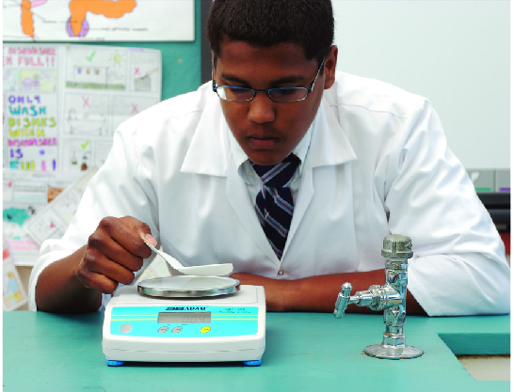

Figure 1Weighing the eggshells allows you to calculate the mass lost in the reaction.

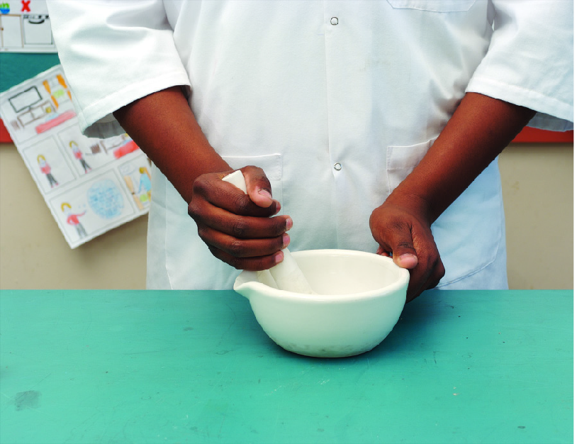

Figure 2Grinding the eggshells creates smaller particles.

Results

Draw an appropriate table for your results using the space provided.

|  |
| --- |
|  |

Discussion

1 Which eggshell dissolved faster?

2 How many times faster was the rate of the reaction for the ground-up eggshell than for the large piece of eggshell?

3 Why do small pieces react faster than one large piece?

4 Why is stirring necessary?

5 Did grinding up the eggshell change the amount of calcium carbonate in it?

Conclusion

What do you know about how particle size affects reaction rate?

Experiment worksheet

5.4 Heat can speed up a reaction

Pages 86–87 and 194

Experiment 5.4B: Speeding up reactions with enzymes

Hydrogen peroxide breaks down into oxygen and water slowly over time. Yeast has a catalyst that speeds up this reaction.

Aim

To investigate the effect of enzymes on breaking down hydrogen peroxide.

Materials

• 1 packet of dried yeast

• 200 mL beaker

• 10 mL hydrogen peroxide (3%)

• 1 splint

• Matches

Method

1 Add the yeast into the beaker.

2 Add 10 mL of the hydrogen peroxide into the beaker.

3 Light the splint and then blow it out. Place the glowing splint in the top half of the beaker.

4 Record your observations.

Results

Record your observations in a table below.

|  |
| --- |
|  |

Discussion

1 Was the breakdown of hydrogen peroxide into oxygen and water noticeable before the yeast was added?

2 What happened to the rate of hydrogen peroxide breakdown when the yeast was added?

3 What effect did the gas produced have on the glowing splint?

4 What gas would cause this reaction?

Conclusion

What do you know about how enzymes affect the rate of a reaction?

Experiment worksheet

5.5 Many substances exist because of the work of scientists

Pages 88–89 and 195

Experiment 5.5: Making casein glue

Casein is a protein in milk. It can be extracted from milk and chemically changed so it has the properties of a glue.

Aim

To improve the manufacture of casein glue.

Materials

• Full cream milk (70 mL for each group of students)

• 250 mL beaker

• Bunsen burner and heating mat

• Tripod stand and gauze mat

• Matches

• Thermometer

• Heatproof glove

• Vinegar (20 mL)

• Stirring rod

• Sieve

• Disposable cleaning cloth

• 15 mL warm water

• ½ teaspoon baking powder

• Icy pole sticks (for gluing together)

Method

1 Pour 70 mL of milk into the 250 mL beaker.

2 Set up your Bunsen burner and heat the milk to no more than 50°C. Remove the milk from the heat using a heatproof glove.

3 Slowly add 20 mL of vinegar to the milk, with gentle stirring. Do not stir vigorously as you will break up the curd (lumpy bits) being formed. The curd should clump as much as possible.

4 Set up the sieve over the sink or a large beaker. Put a piece of disposable cloth over the sieve.

5 Gently pour the mixture through the cloth and sieve to filter the whey (liquid) from the curds (lumps of mainly protein). Once it has stopped dripping, very gently squeeze the cloth to remove any excess liquid.

6 Return the solids to the original 250 mL beaker and crush the curds with a glass stirring rod to break them up as much as possible.

7 Add 15 mL of warm water and stir until it has an even consistency. Add ½ teaspoon of baking powder.

8 Take your sample and two icy pole sticks to your bench.

9 Spread your sample between the sticks and press them together. Leave them overnight and then test how well your glue has worked.

Inquiry: Choose one of the questions below to investigate.

• What if skim milk was used?

• What if soy milk was used?

• What if more vinegar was used?

• What if more baking powder was added?

Answer the following questions in relation to your inquiry.

• Write a hypothesis for your question.

• What (independent) variable will you change from the first method?

• How will you determine which glue is stronger?

• Name three variables you will keep the same/control.

Results

Record your observations and measurements in a table using the space provided.

|  |
| --- |
|  |

Discussion

1 Why is it important to wear safety glasses in this experiment?

2 What are the reactants used in this experiment? What are the products?

3 How could you compare the strength of different glues?

4 How do you think someone worked out that you could make glue from milk?

Conclusion

What do you know about making glue?